ICT LAB ASSIGNMENT TASK 7
BS CYFS 2025
Name: Ibrahim Bin Arif
Roll no: 2503541
Intro to Python:
Task 1: Original Code:
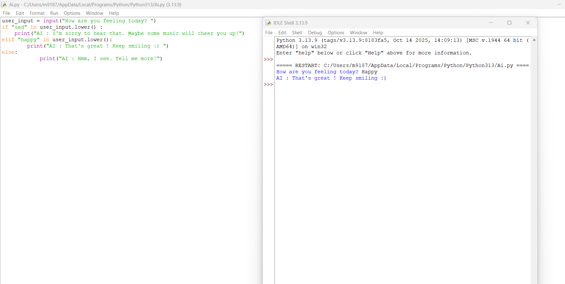
Modified Code:
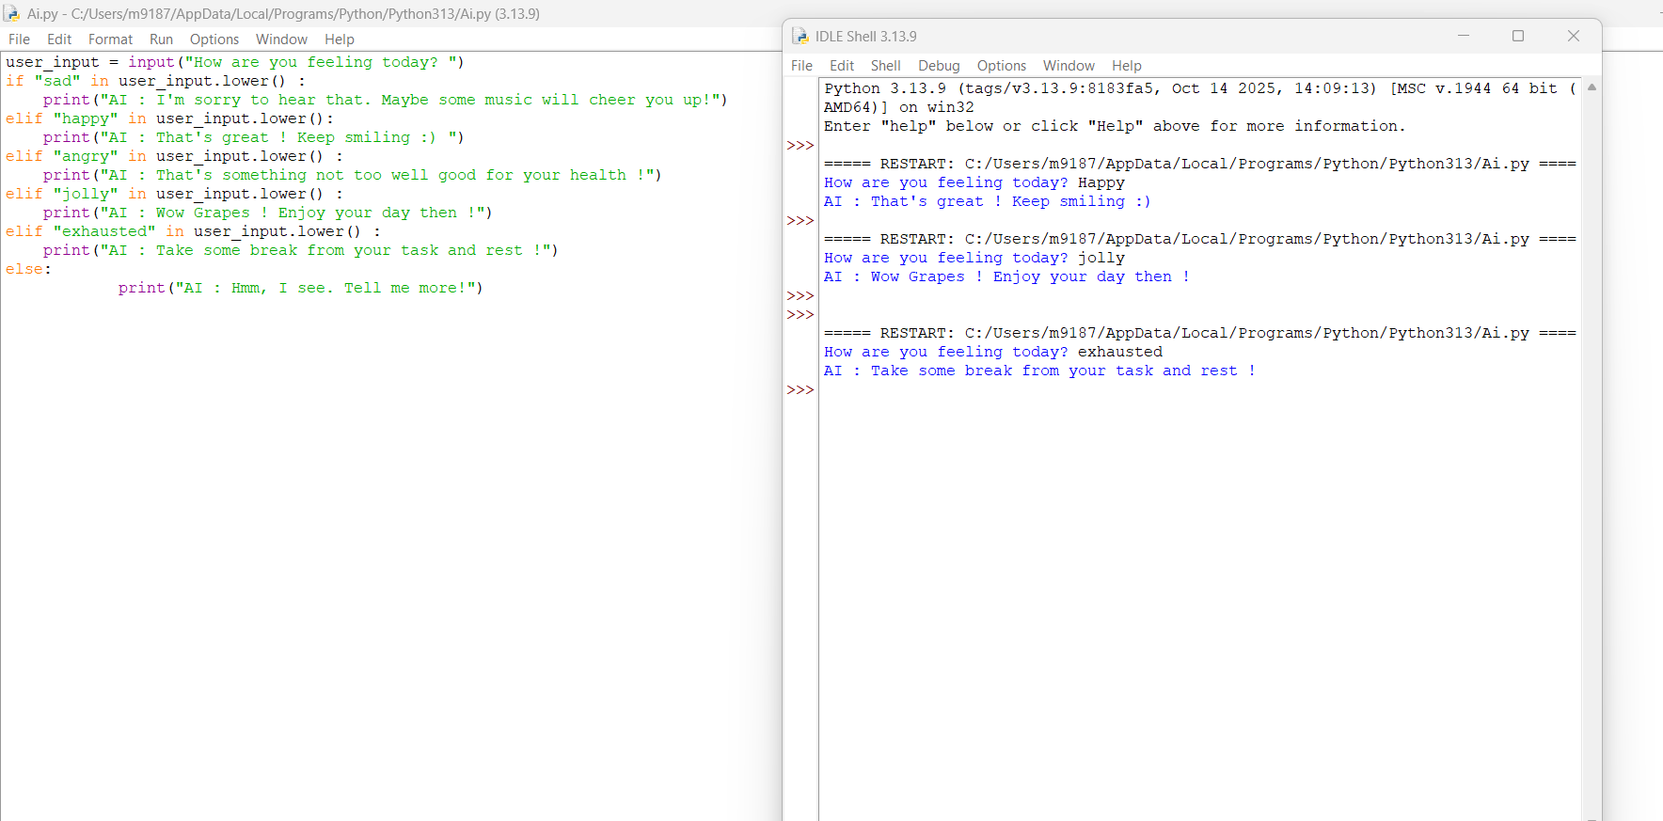
Task 2: Original Code:
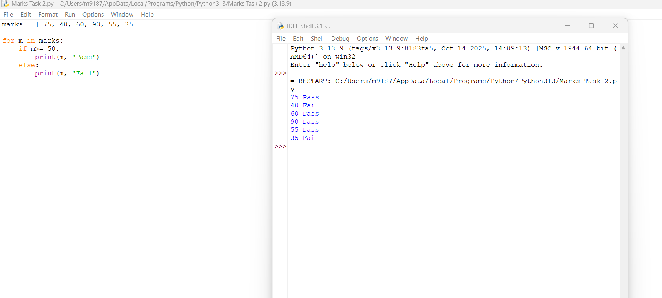

Modified Code:
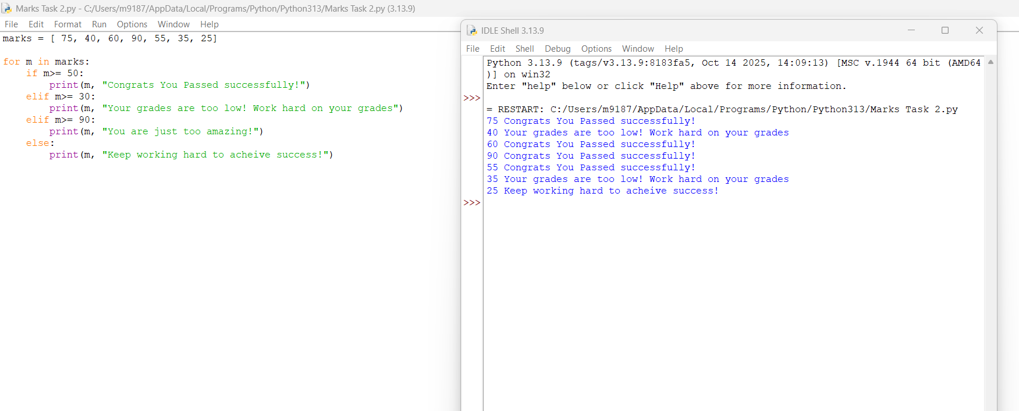

Task 3: Original Code:
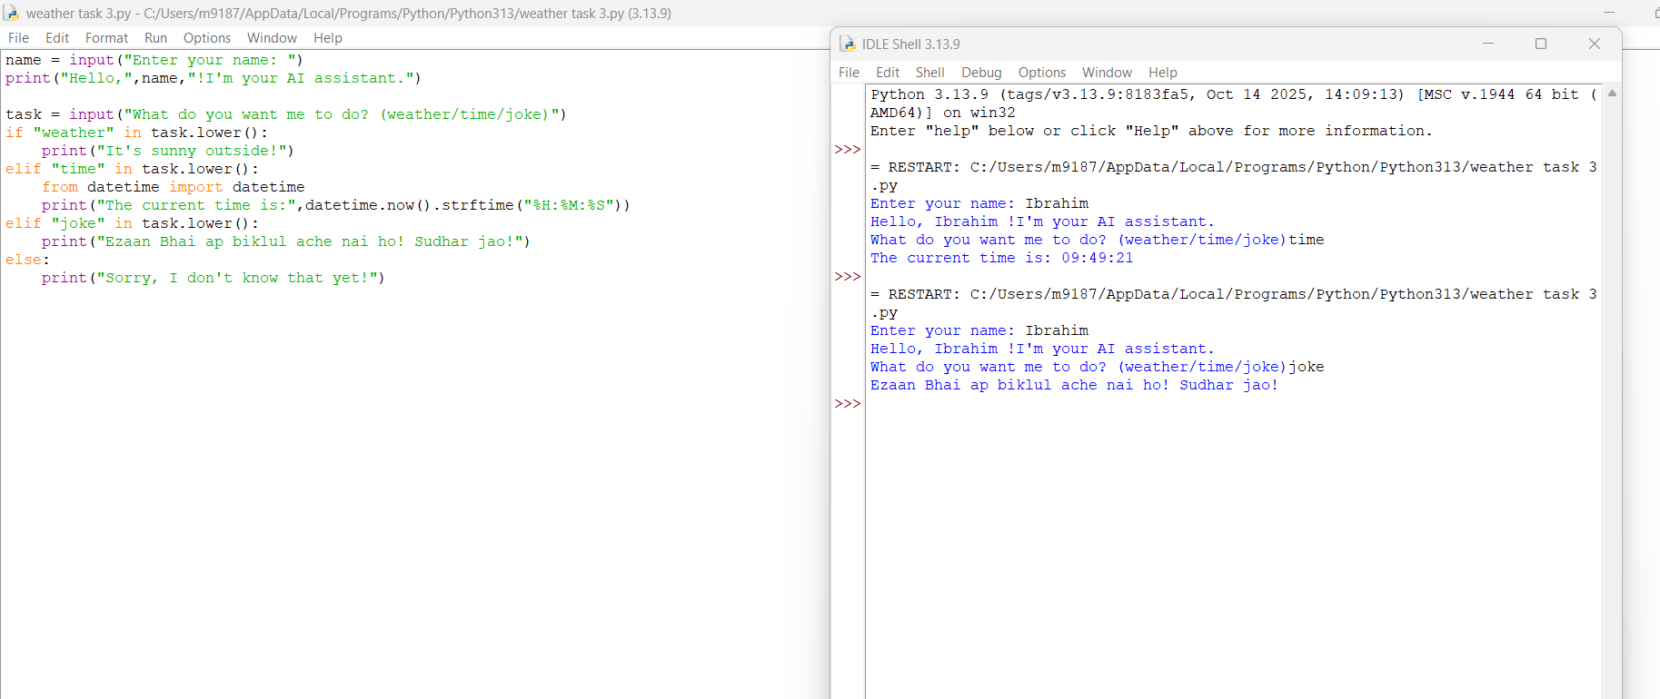

Modified Code:
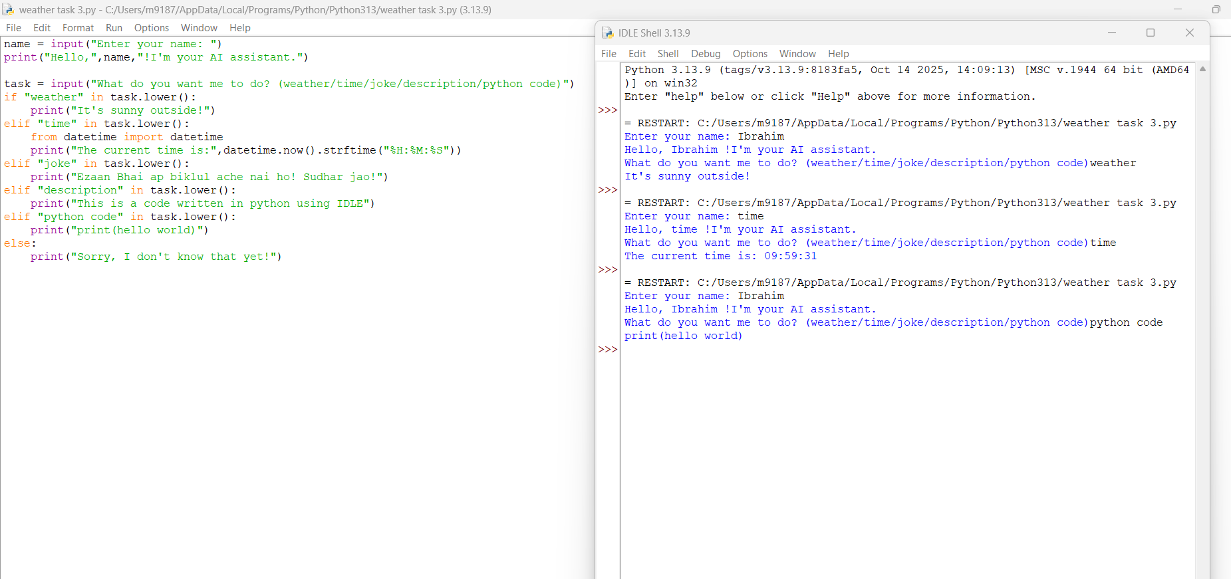

Task 4: Original Code
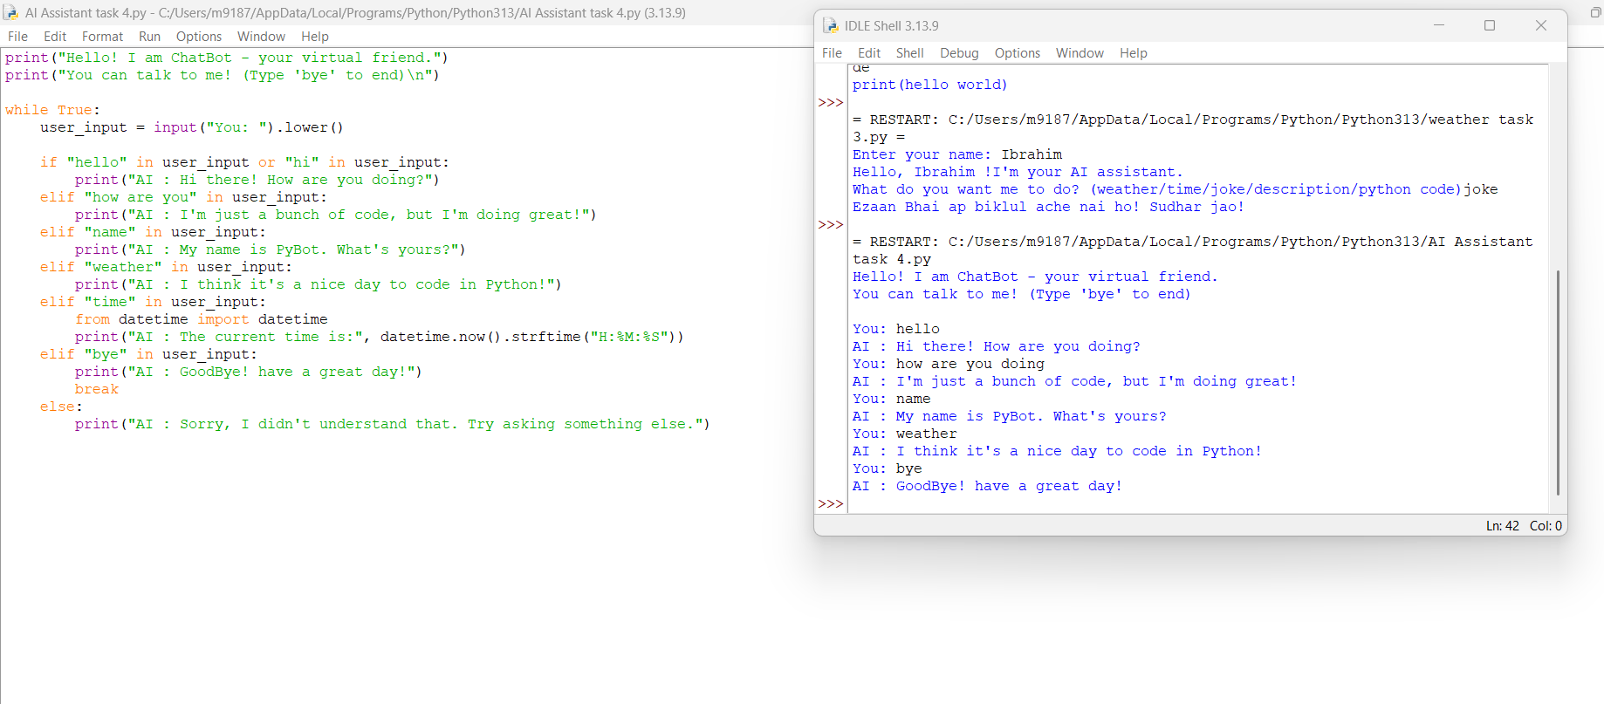
Modified Code:
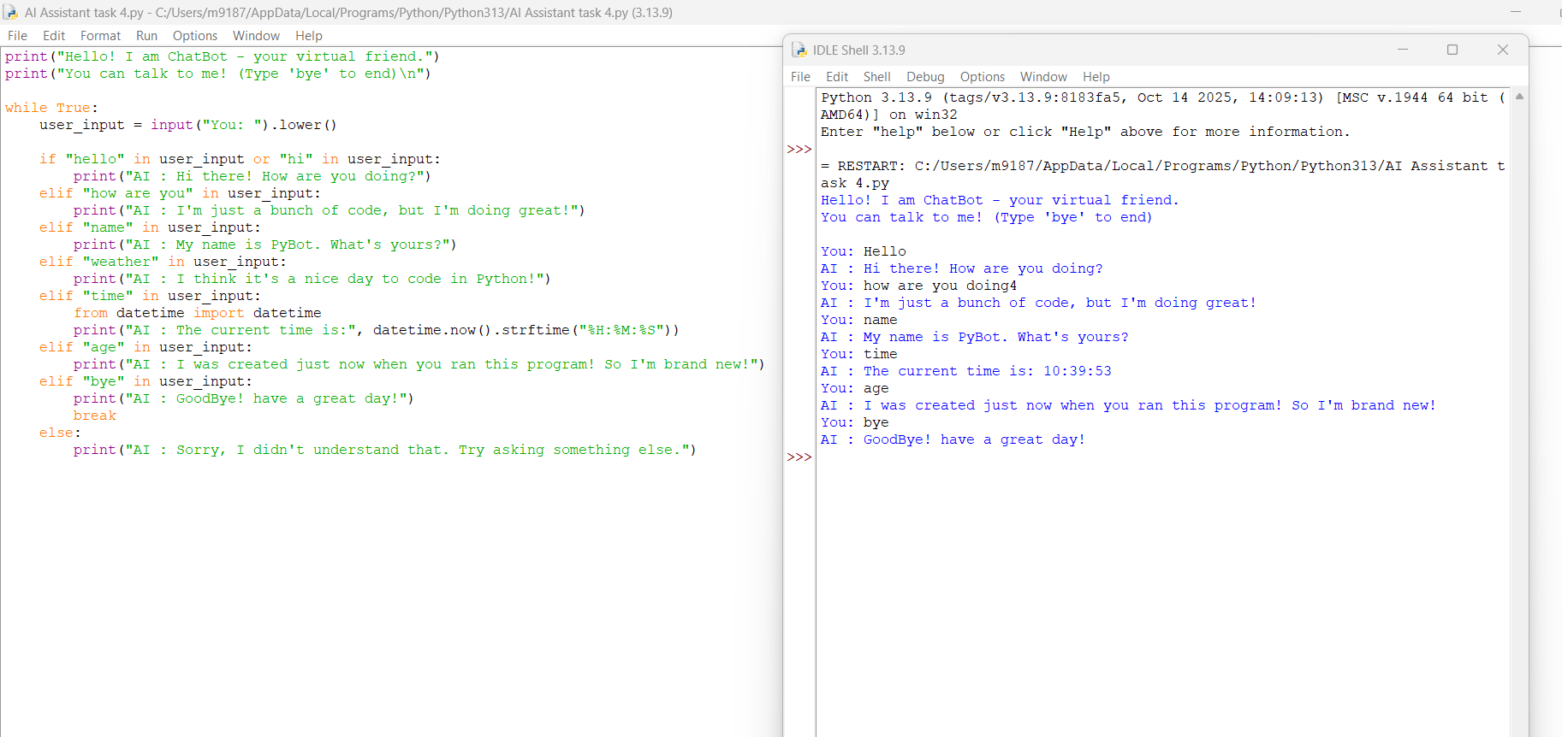

THE END

